PowerShell Template – 3 NIC 2 vThunder HA Test Cases

Table of Contents

Resource Creation 2

Resource Group 2

Storage Account 2

Interfaces 3

Subnets 3

Virtual Network 3

Public Ips 4

NSGs 6

vThunder Instances 7

vThunder Networking Configuration on Azure 8

vThunder-1 8

vThunder-2 9

PowerShell Template Input 10

PowerShell Template User Authentication 11

vThunder IP Configuration 11

vThunder SLB Configuration 12

vThunder-1 12

vThunder-2 13

vThunder SSL Configuration 13

vThunder-1 13

vThunder-2 13

vThunder HA Configuration 14

vThunder-1 14

vThunder-2 14

vThunder DNS and IP Route Configuration 14

SLB and HA Test Cases 14

Without failover (vThunder-1 is in active and vThunder-2 is in standby mode) 15

vThunder-1 goes on standby mode 16

vThunder-1 again become active 17

vThunder-1 and vThunder-2 both are on standby mode 18

PS Template – 3 NIC 2 vThunder HA GLM Test Cases 18

License Activation 18

Activate license 18

Apply GLM license 18

Set GLM configuration 19

# Resource Creation

## Resource Group

* + 1. Expected Outcome: 1 resource group should get created if not exists else existing resource group will be used.
    2. Actual Outcome:
       1. 1 new resource group name “vikas-test-ARM-rg” is created when it was not present.

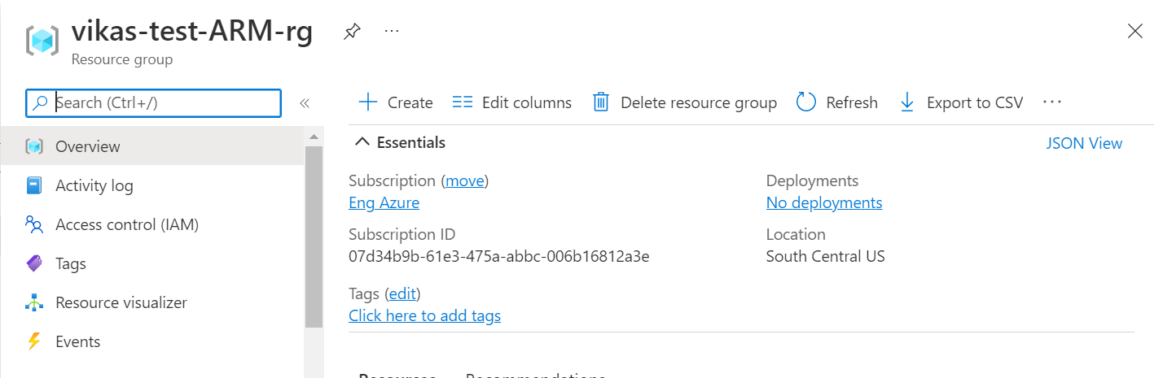

* + - 1. When resource group is “vikas-test-ARM-rg” is present then resource group is used.

## Storage Account

* + 1. Expected Outcome: 1 storage account should get created if not exists else existing storage account will be used.
    2. Actual Outcome:
       1. 1 storage account name “vikasteststo” is created when not already present.

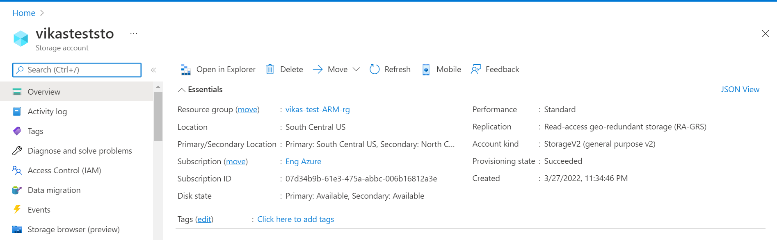

* + - 1. When storage account “vikasteststo” already exists then it is used.

## Interfaces

* + 1. Expected Outcome: 6 interfaces (2 management, 4 data interfaces)should get created, and each interface is from different subnet.
    2. Actual Outcome: 6 interfaces are created and attached to VMs.
       1. 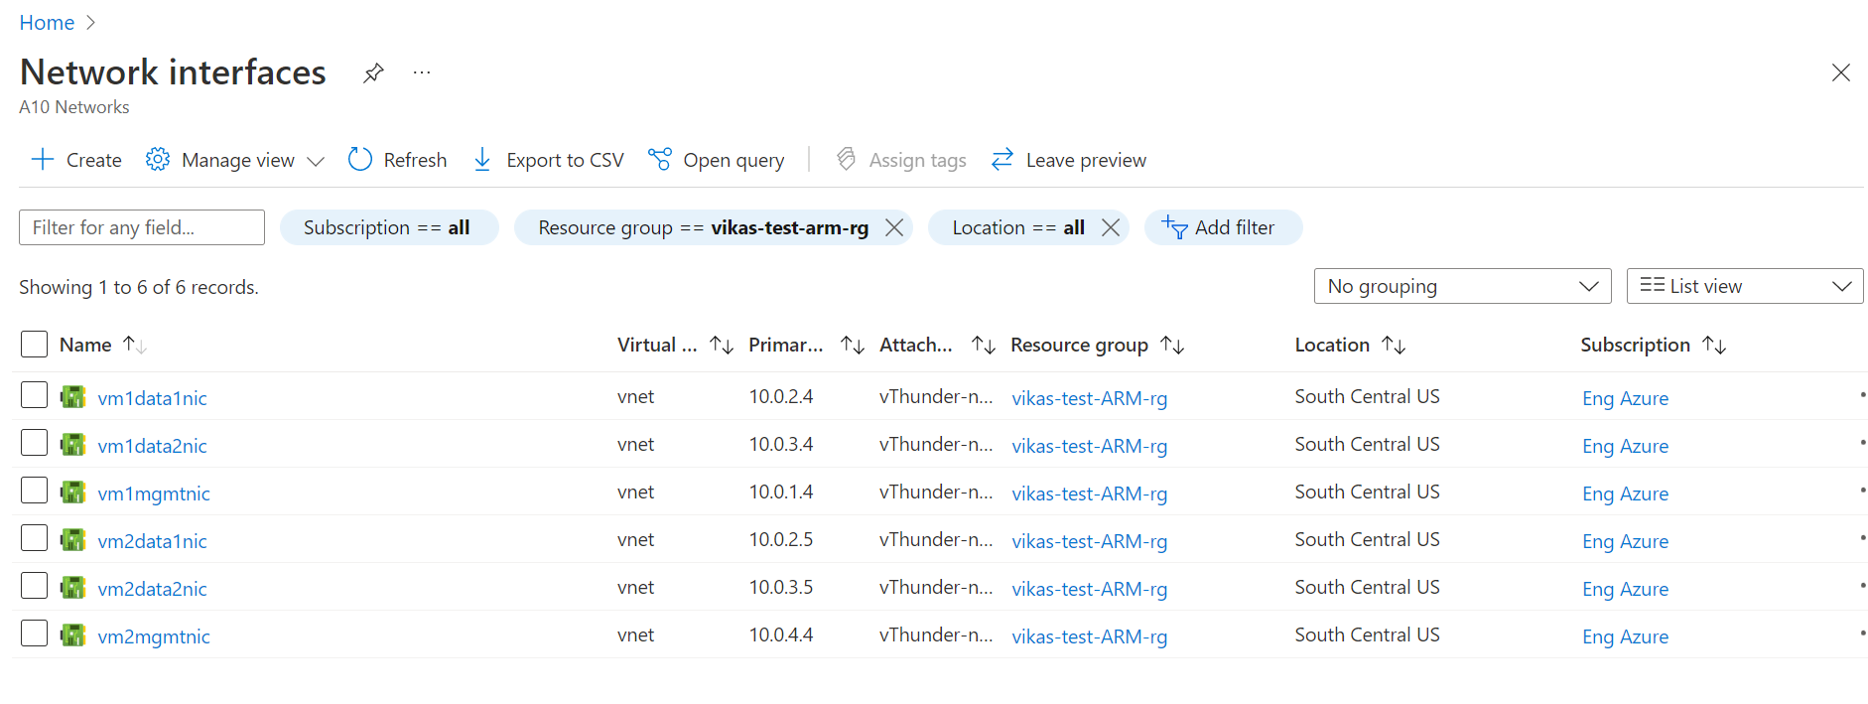

## Subnets

* + 1. Expected Outcome: 3 subnets should get created.
    2. Actual Outcome: 3 subnets are created.

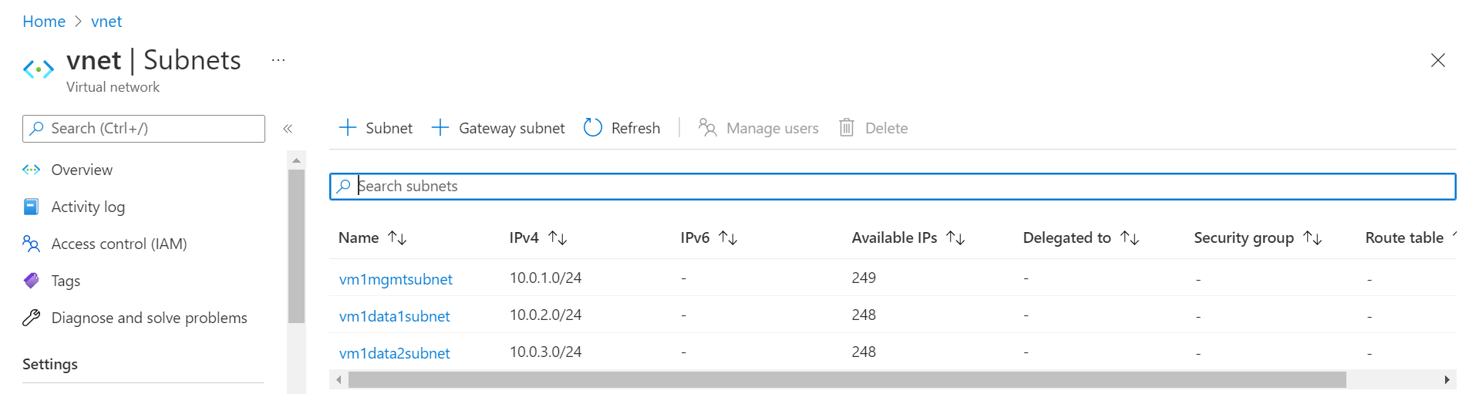

## Virtual Network

* + 1. Expected Outcome: 1 virtual network should get created if not exists else present virtual network will be used.
    2. Actual Outcome: 1 virtual network is created name “vnet”.

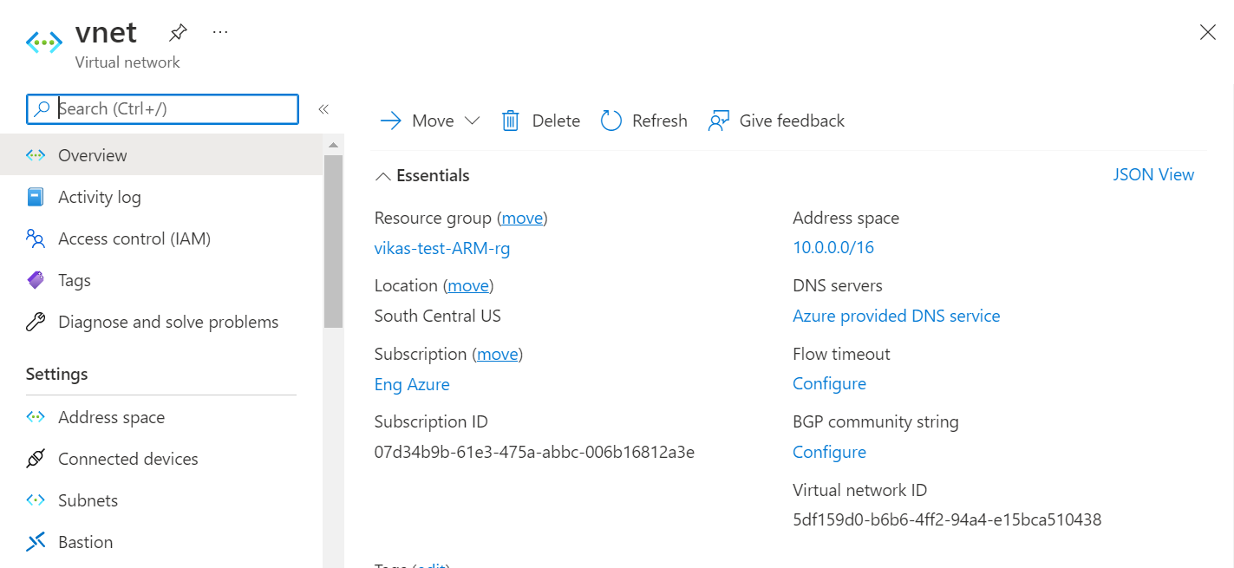

## Public Ips

* + 1. Expected Outcome: Either 2 public ips or 6 public ips should get created according to user input.
    2. Actual Outcome:
       1. User will get option on PowerShell terminal to either create 2 public ips and attached to management interfaces
          1. 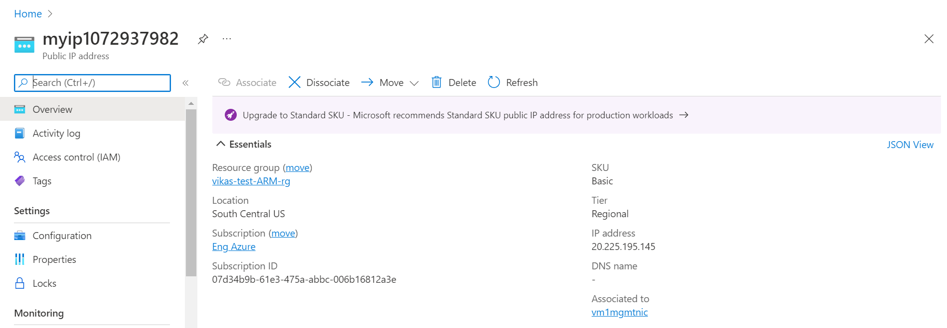
          2. 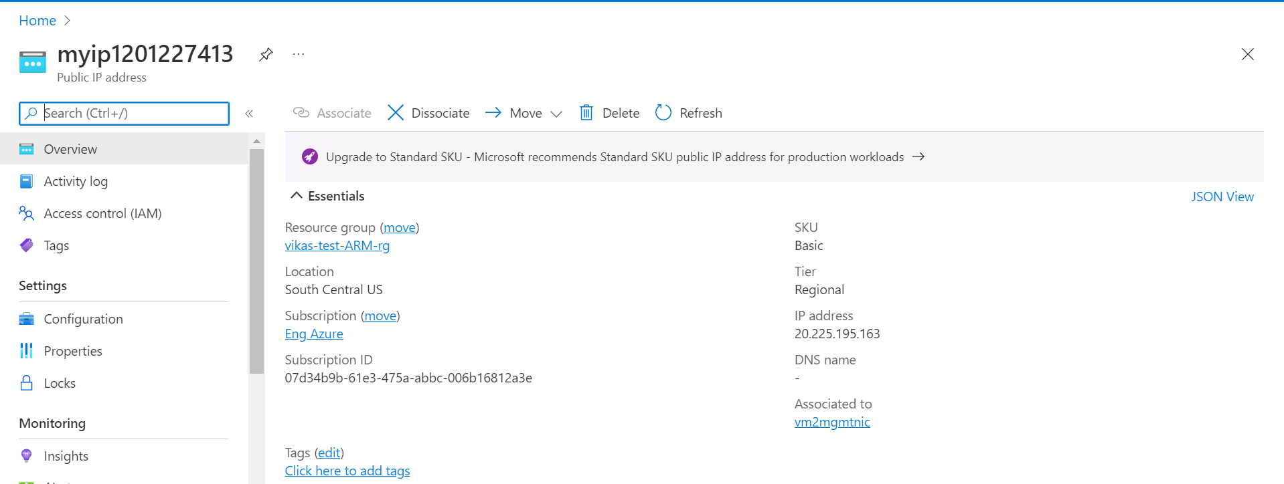
       2. Or 6 public ips is created and attached to all interfaces.
          1. 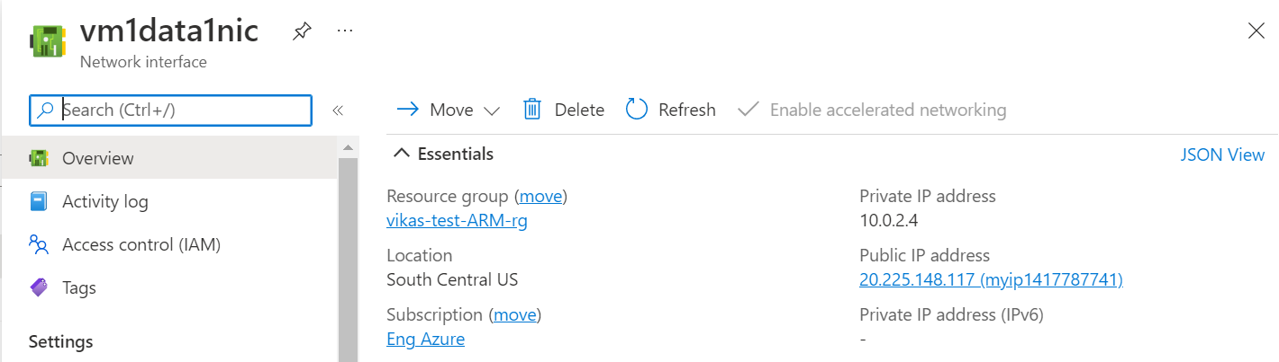
          2. 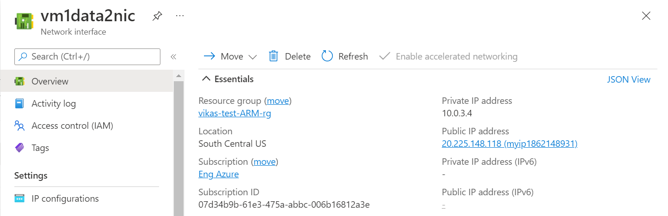
          3. 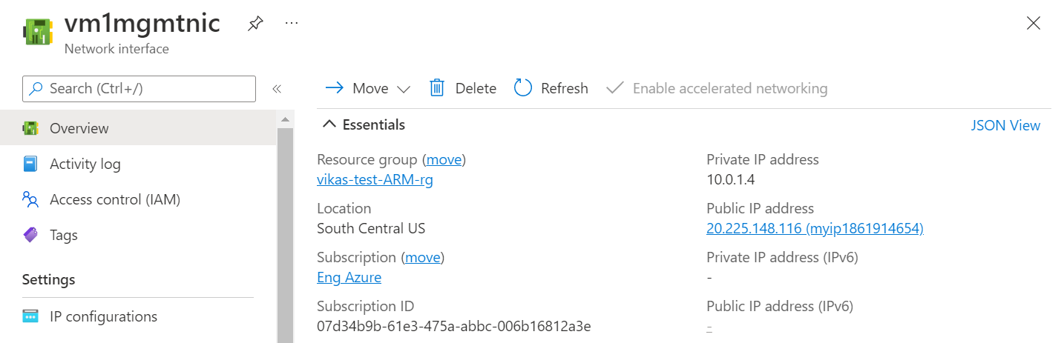
          4. 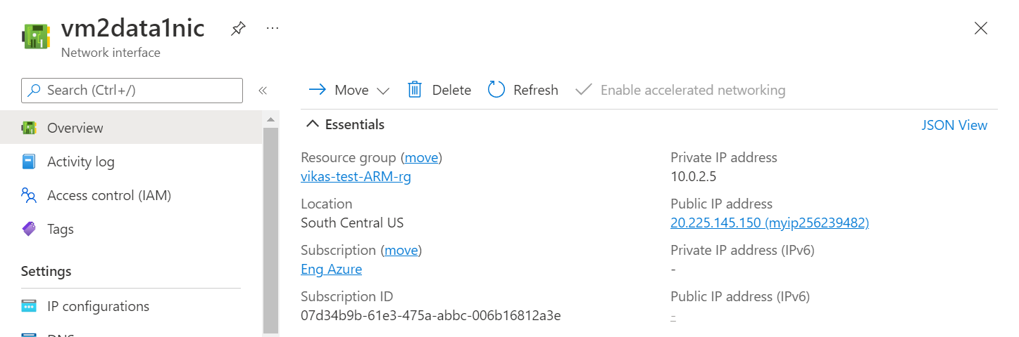
          5. 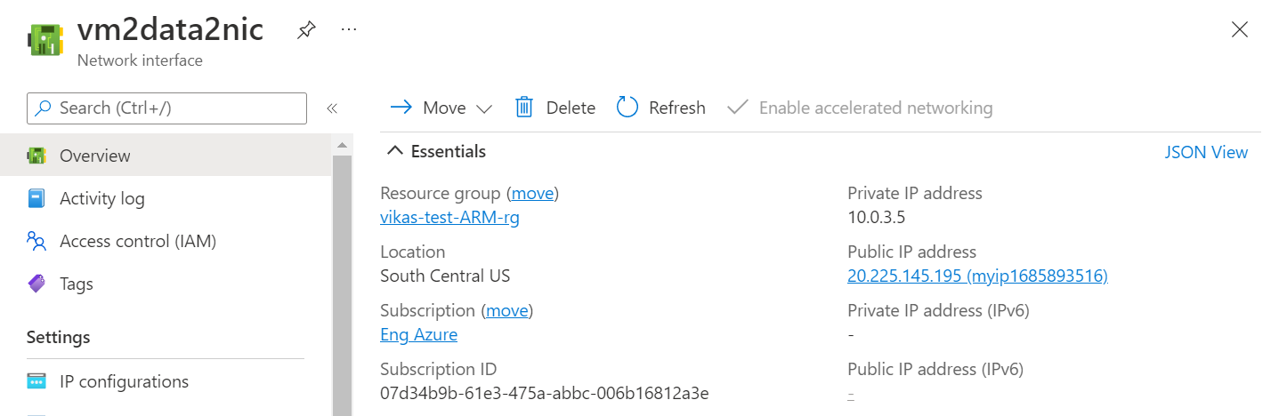
          6. 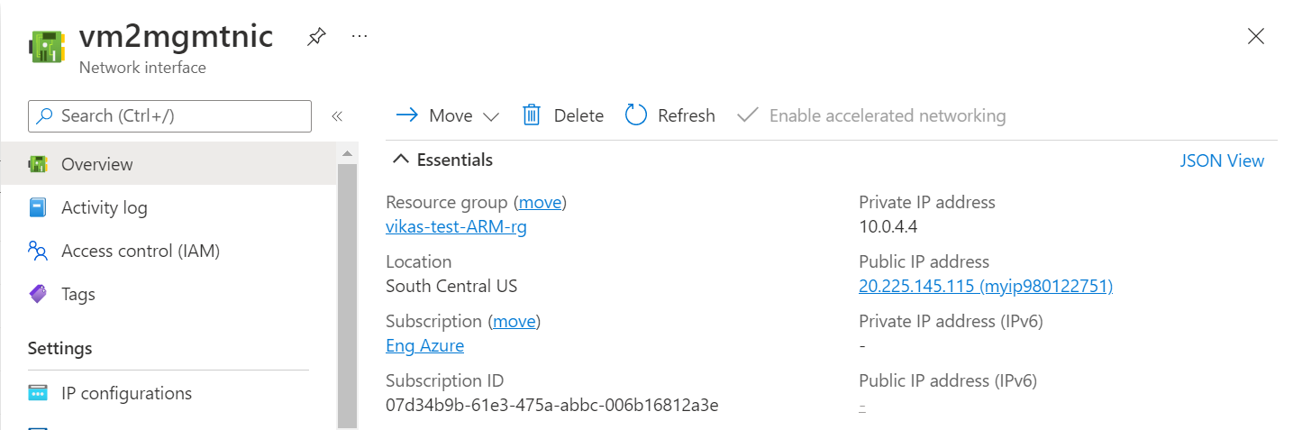

## NSGs

* + 1. Expected Outcome: 2 NSG should get created (1 for vm 1 and another for vm2 )
    2. Actual Outcome: 2 NSG is created and attached to VMs.
       1. 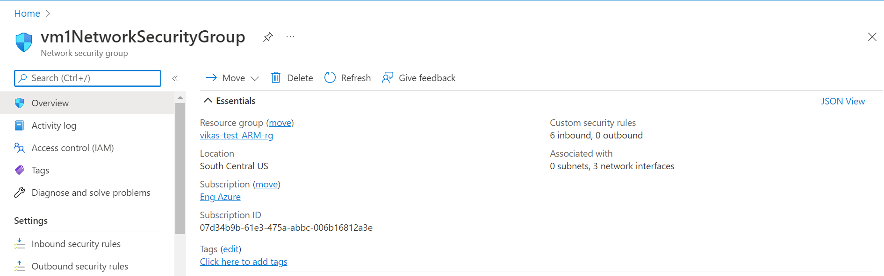
       2. 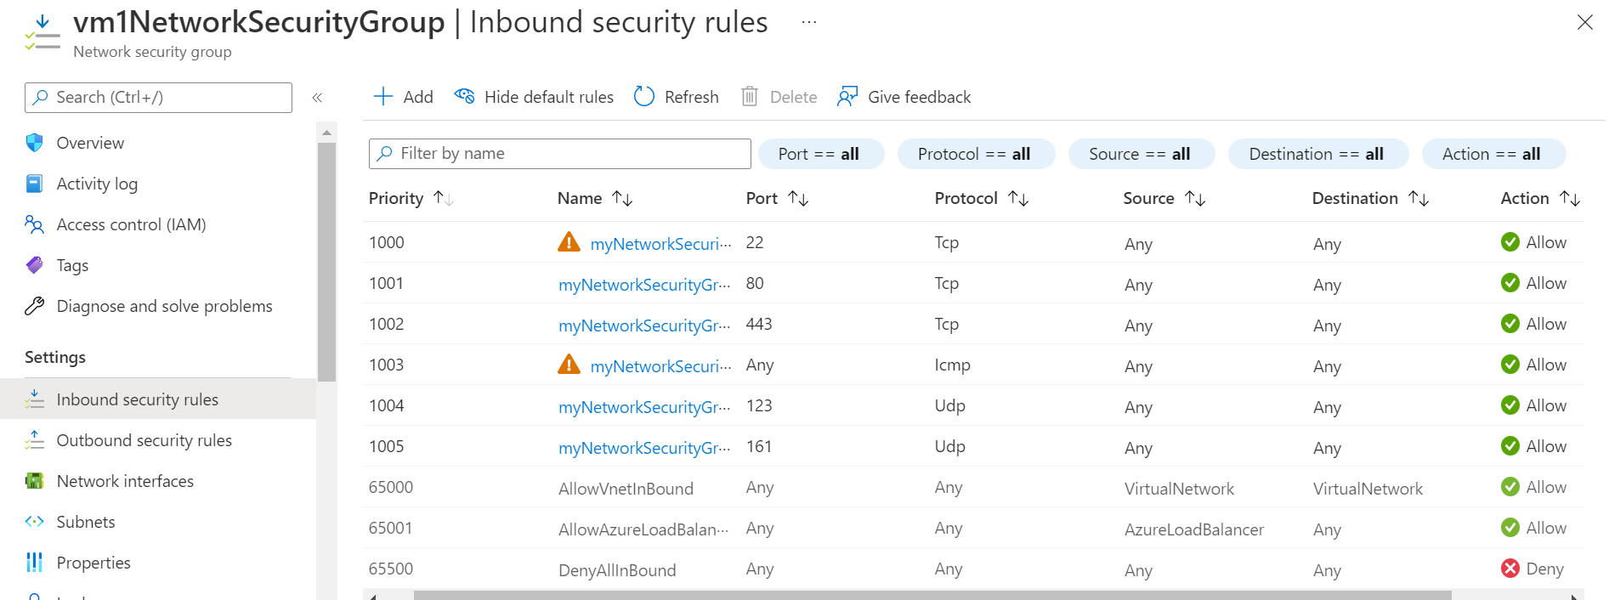
       3. 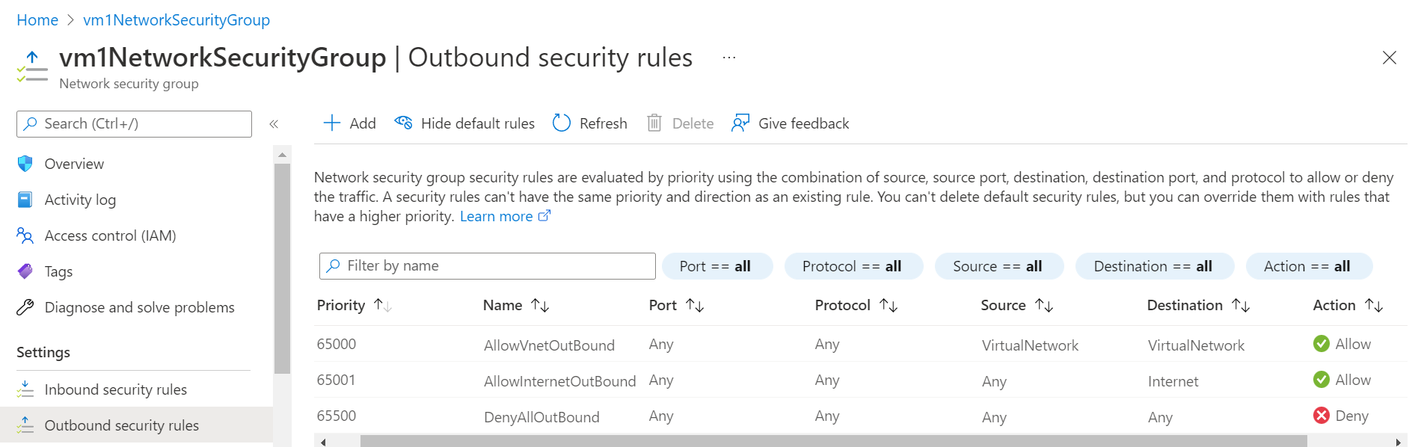
       4. 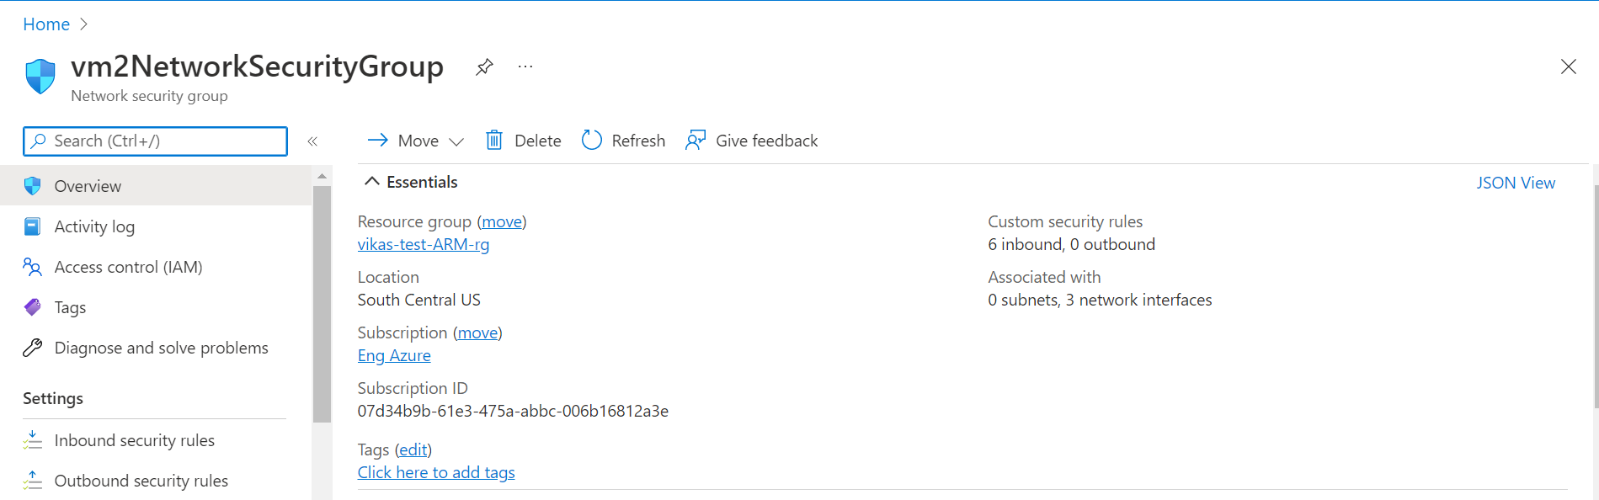
       5. 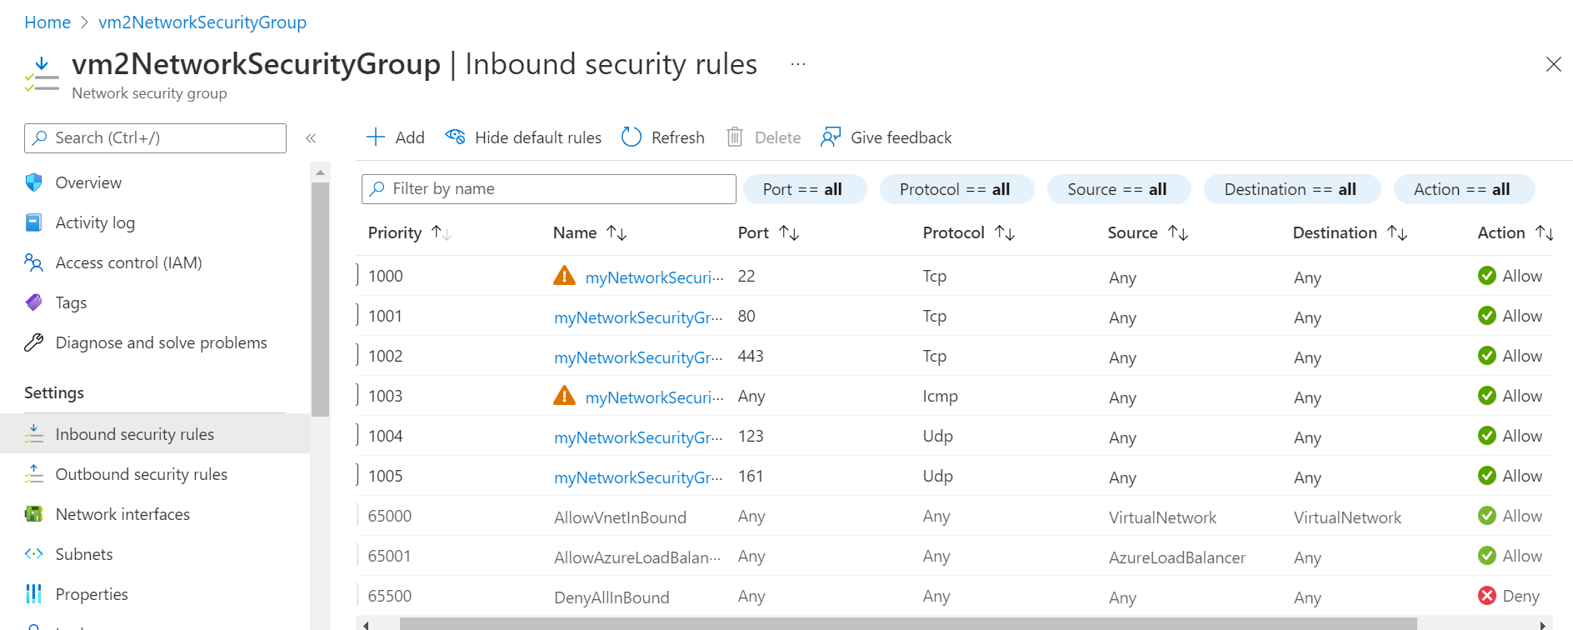
       6. 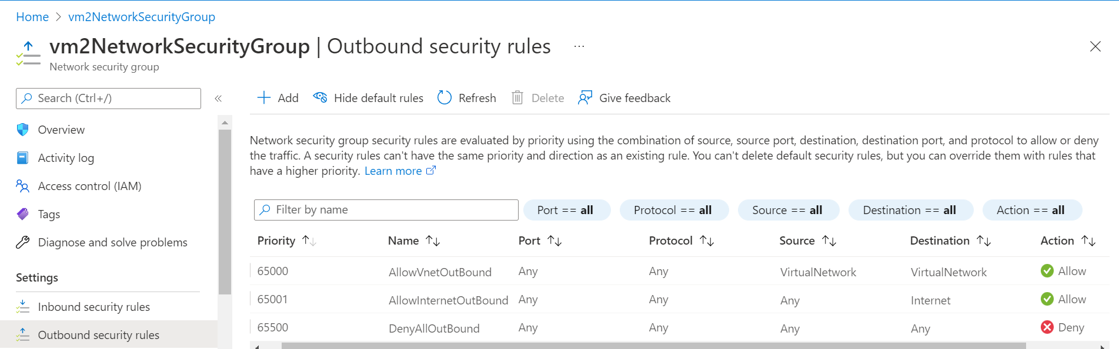

## vThunder Instances

* + 1. Expected Outcome: 2 vThunder instances should get created having same configuration.
    2. Actual Outcome: 2 vThunder instances are created having same configuration.
       1. 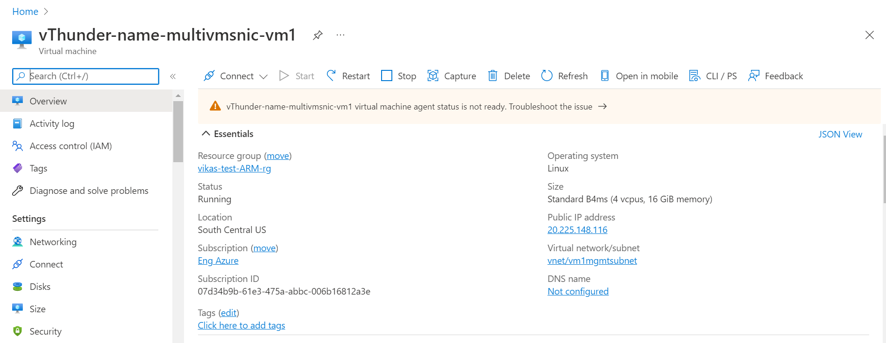
       2. 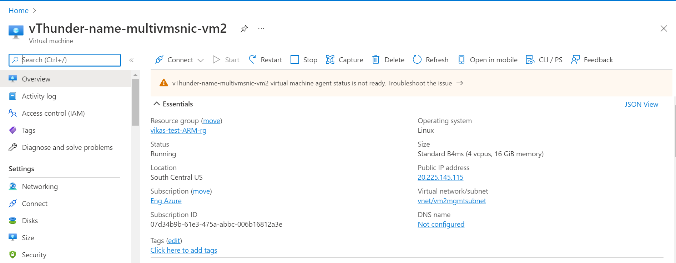

# vThunder Networking Configuration on Azure

## vThunder-1

* + 1. Management Interface
       1. Expected Outcome: Management interface will have only primary Ip, no secondary Ip.
       2. Actual Outcome: Management interface has only primary Ip.
          1. 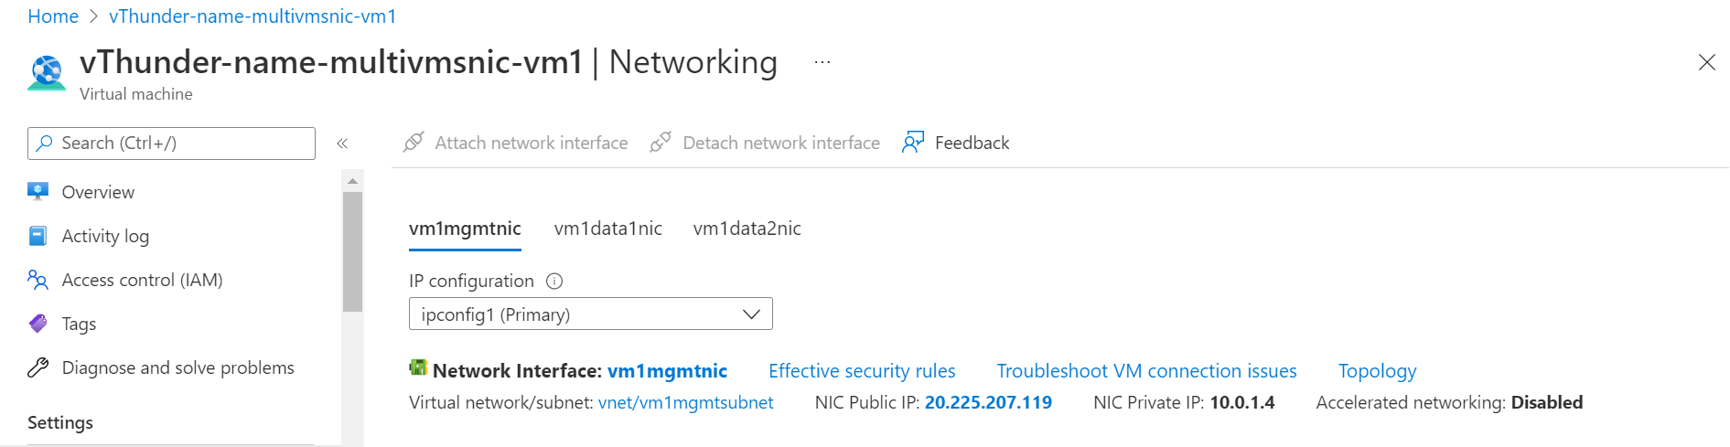
    2. Data Interface (Client Side)
       1. Expected Outcome: Client side data interface will have 1 primary Ip and 1 private secondary Ip (named VIP).
       2. Actual Outcome: Client side data interface has 1 primary Ip and 1 private secondary Ip (named VIP)
          1. 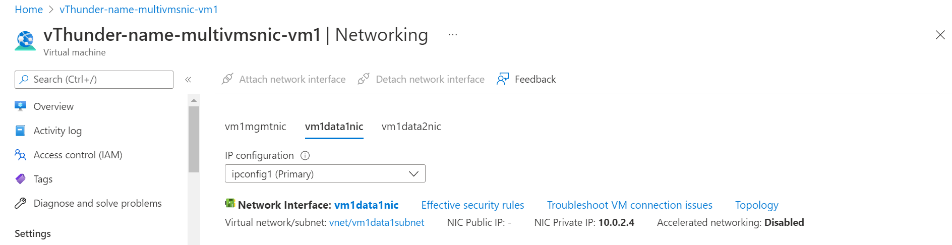
          2. 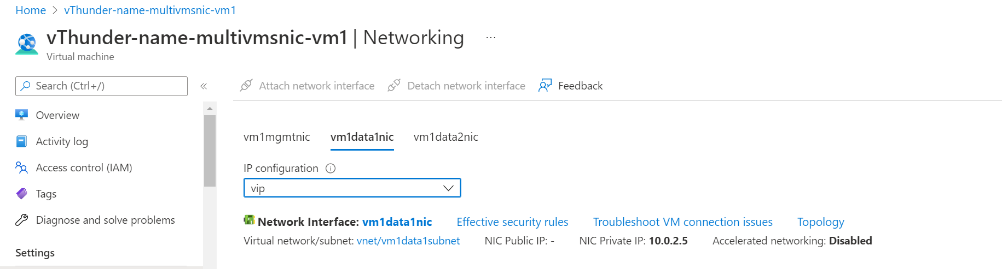
    3. Data Interface (Server Side)
       1. Expected Outcome: Server side interface will have 1 primary Ip and 1 private secondary Ip (named fip)
       2. Actual Outcome: Server side interface has 1 primary Ip and 1 private secondary Ip (named fip)
          1. 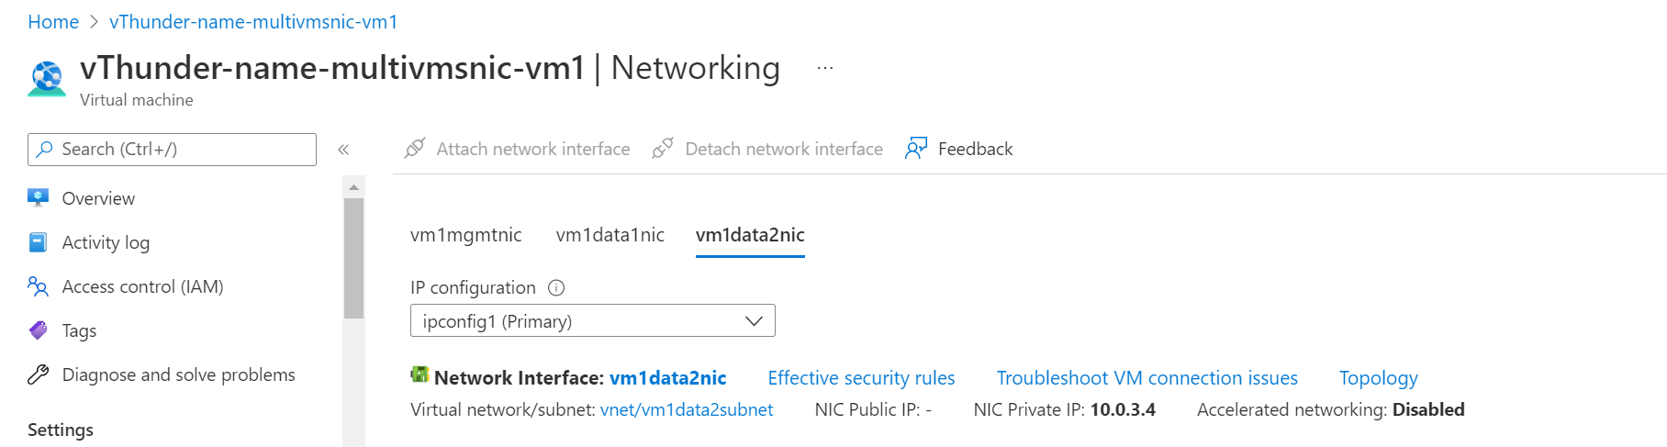
          2. 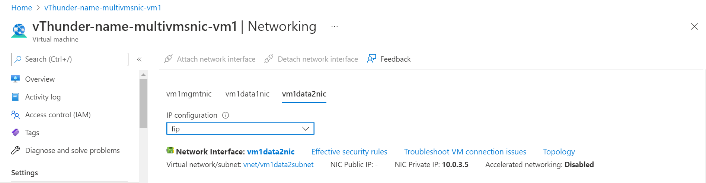

## vThunder-2

* + 1. Management Interface
       1. Expected Outcome: Management interface will have only primary Ip address.
       2. Actual Outcome: Management interface has only primary Ip address.
          1. 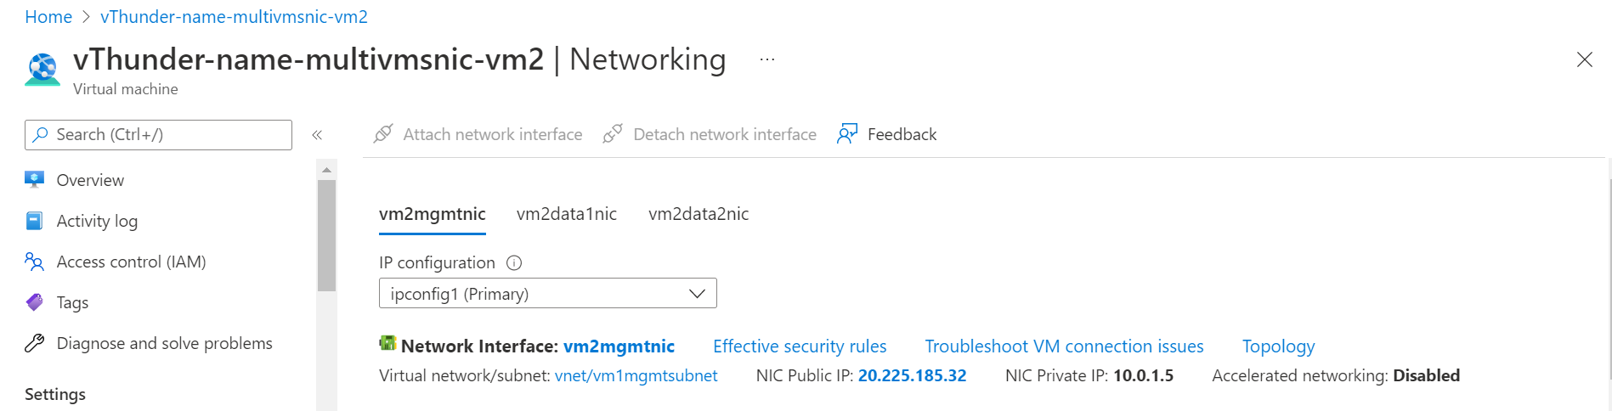
    2. Data Interface (Client Side)
       1. Expected Outcome: Client side interface will have only primary Ip, no secondary Ip.
       2. Actual Outcome: Client side interface has only primary Ip, no secondary Ip.
          1. 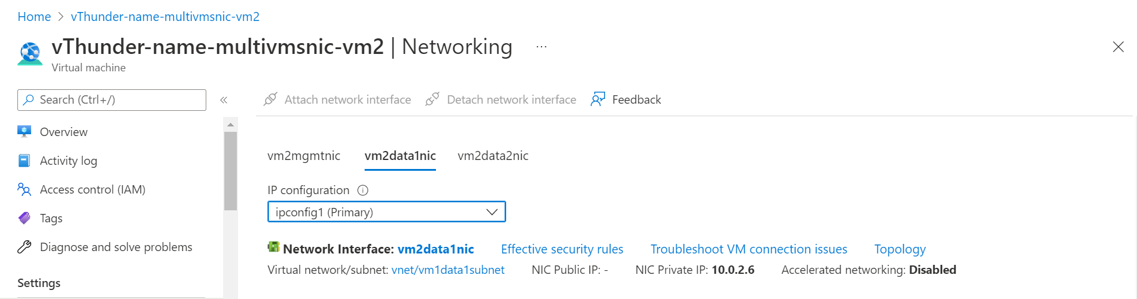
    3. Data Interface (Server Side)
       1. Expected Outcome: Server side interface will have only primary Ip, no secondary Ip.
       2. Actual Outcome: Server side interface has only primary Ip, no secondary Ip.
          1. 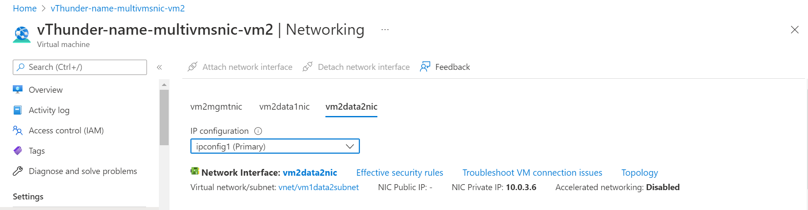

# PowerShell Template Input

* 1. Expected Inputs: resourceGroup, storageaccount, location, public ips for data interfaces
  2. Actual Inputs: resourceGroup, storageaccount, location, public ips for data interfaces

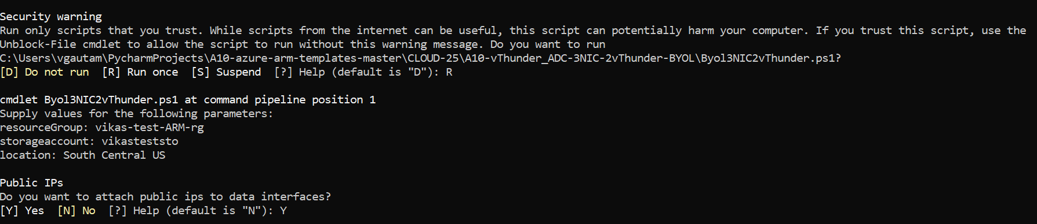

# PowerShell Template User Authentication

* 1. Expected Outcome: User should get pop up to get authenticated with Azure Portal
  2. Actual Outcome: User is getting pop up to get authenticated with Azure Portal
     1. 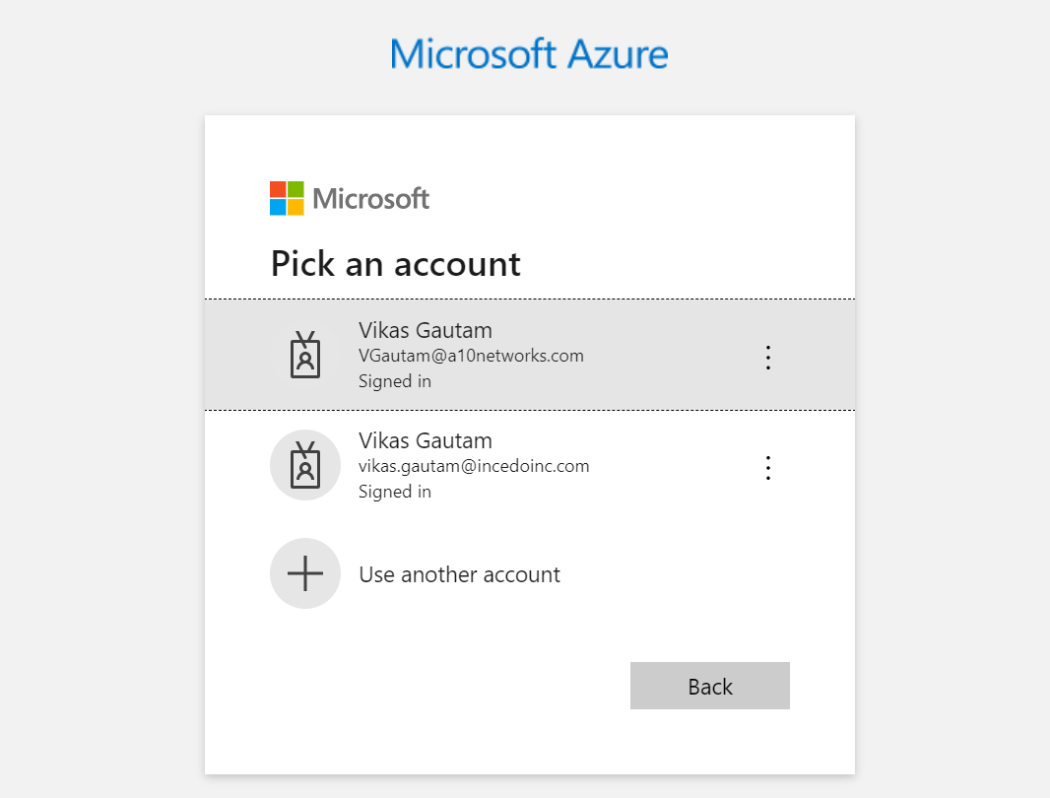

# vThunder IP Configuration

* 1. vThunder-1
     1. 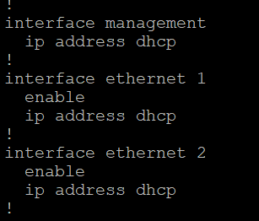
  2. vThunder-2
     1. 

# vThunder SLB Configuration

## vThunder-1

* + 1. 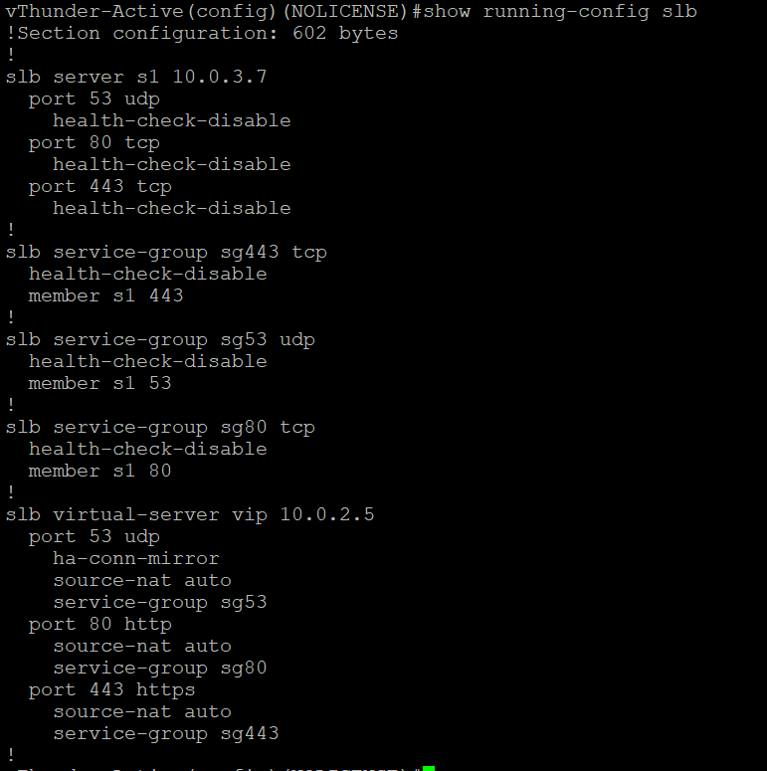

## vThunder-2

* + 1. 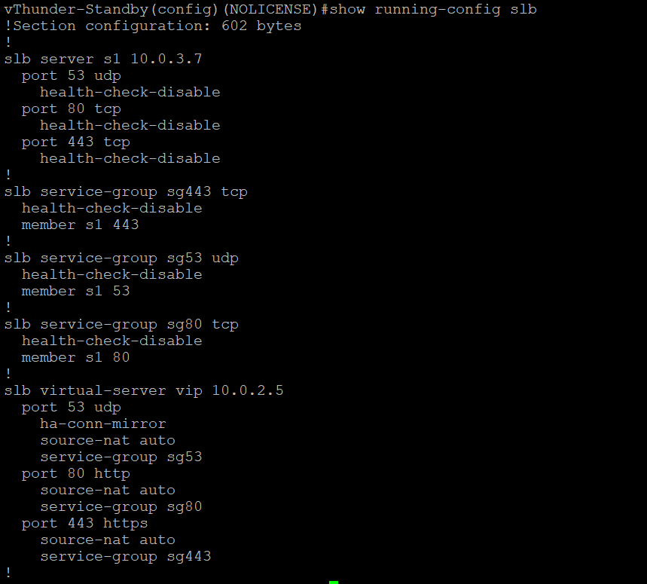

# vThunder SSL Configuration

## vThunder-1

## vThunder-2

# vThunder HA Configuration

## vThunder-1

* + 1. 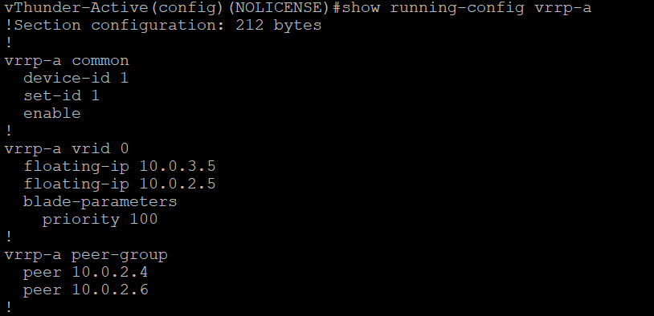

## vThunder-2

* + 1. 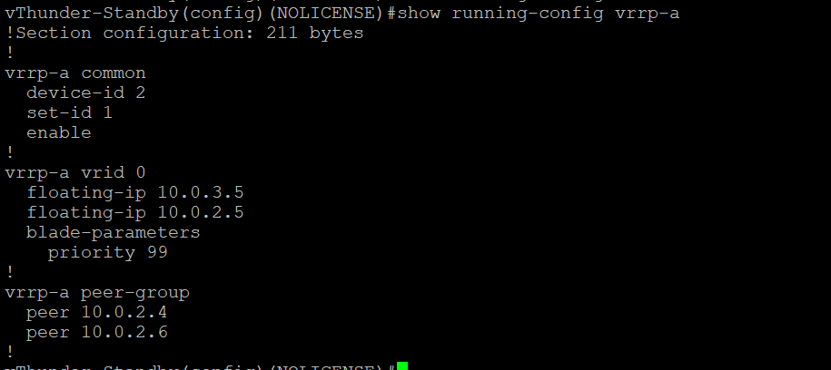

# vThunder DNS and IP Route Configuration

* 1. vThunder-1
     1. 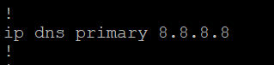
     2. 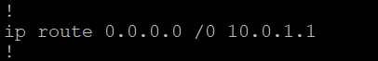
  2. vThunder-2
     1. 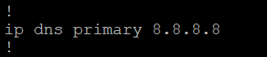
     2. 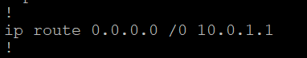

SLB and HA Test Cases

## Without failover (vThunder-1 is in active and vThunder-2 is in standby mode)

* + 1. Expected Outcome: Active vThunder (master) will act as SLB and second vthunder will be on standby mode.
    2. Actual Outcome: Activate vThunder (master) is acting as SLB and second vthunder is on standby mode.
       1. Client VM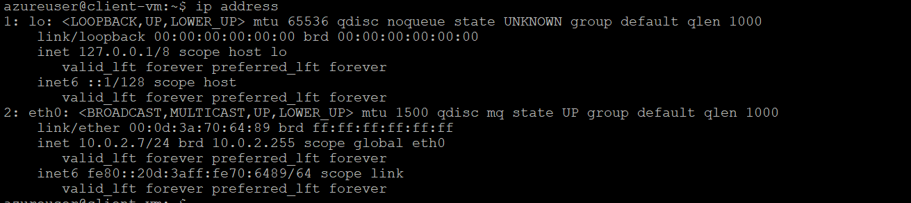
       2. Server VM 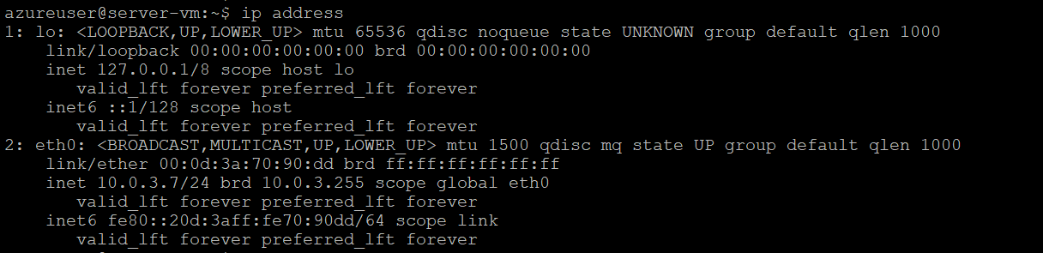
       3. Curl command for client vm to VIP
          1. Expected Outcome: Apache server running on server vm should be accessible from client vm using VIP. VIP should be present as a secondary Ip in client side interface of vThunder-1 and fip should be present as a secondary Ip in server side interface of vThunder-2.
          2. Actual Outcome: Apache server running on server vm is accessible from client vm using VIP. VIP is present in client side interface and fip is present in server side interface.

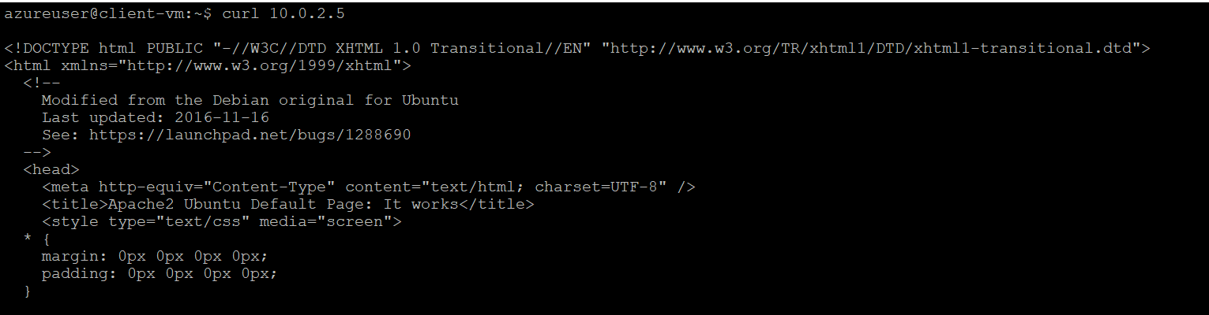

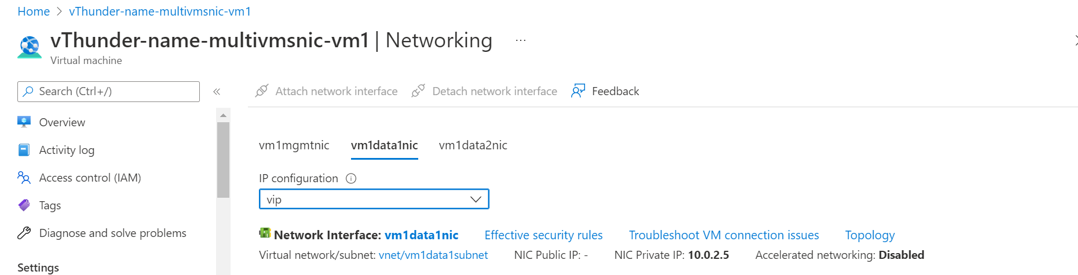

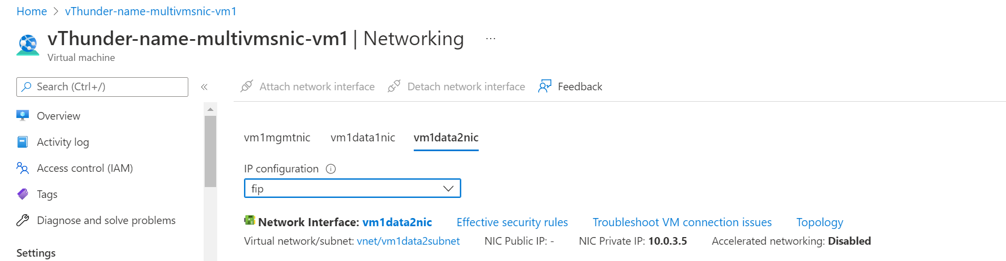

## vThunder-1 goes on standby mode

* + 1. Expected Outcome: vThunder-2 will become active and VIP and fip attached to vThunder-1 will be attached to vthunder-2. Client vm should be able to access Apache server running on server vm using VIP.
    2. Actual Outcome: vThunder-2 is active. VIP and fip attached to vThunder-1 are attached to vthunder-2. Client vm is able to curl Apache server using VIP.
       1. VIP in vThunder-2 client interface 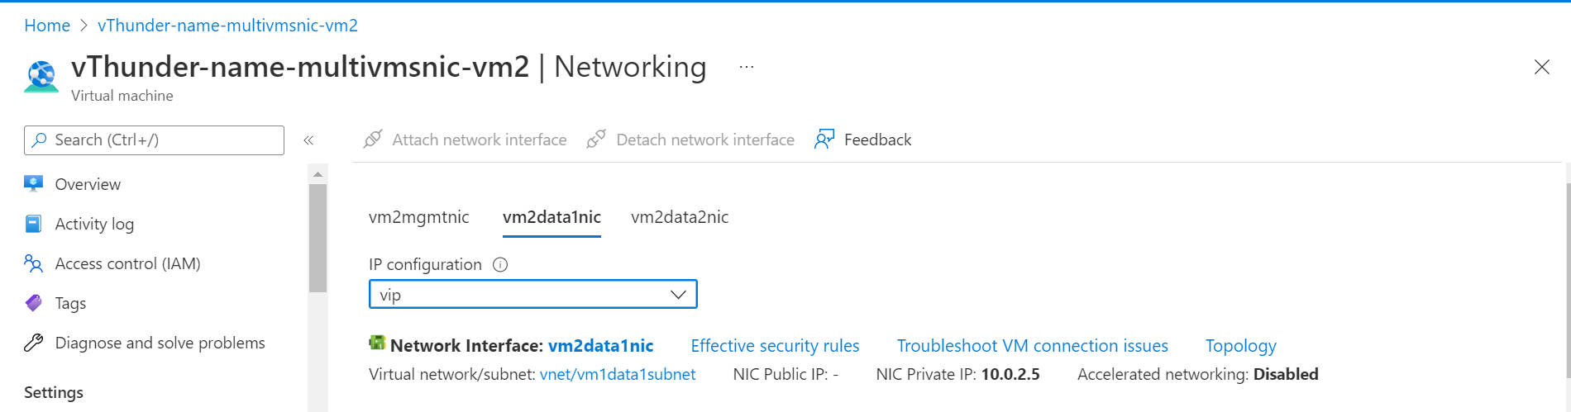
       2. FIP in vThunder-2 server interface 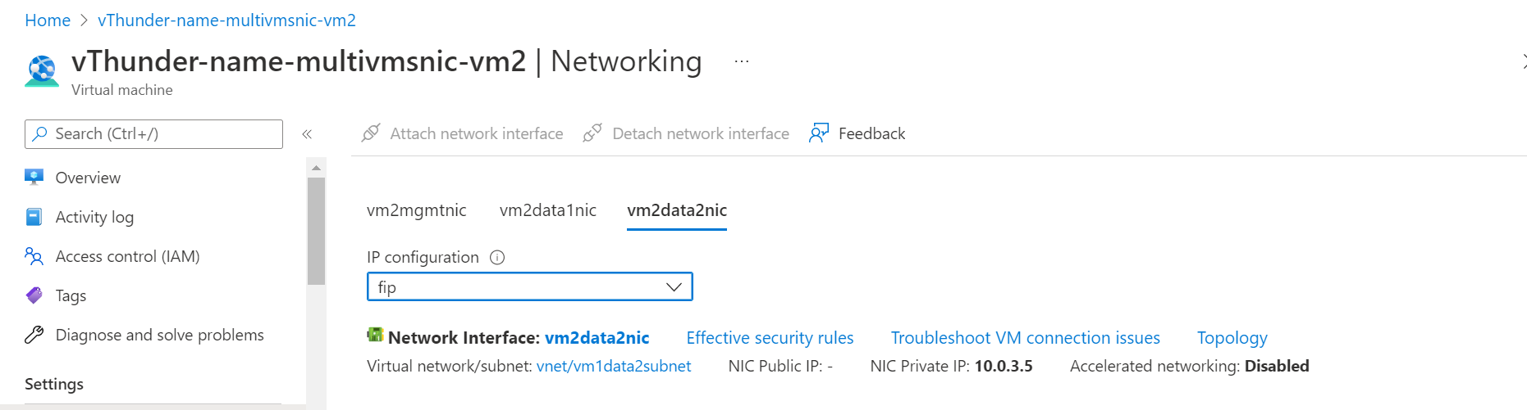
       3. Curl command from client vm to server vm 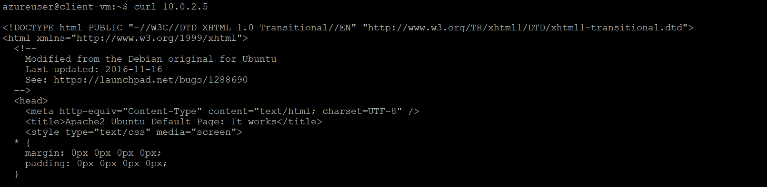
       4. vThunder-1 state 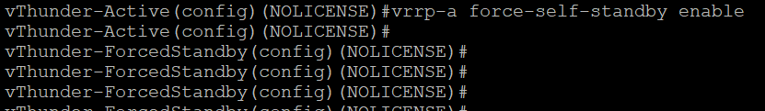
       5. vThunder-2 state 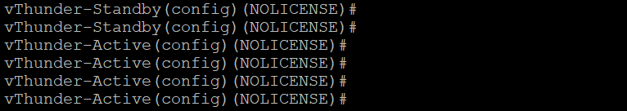

## vThunder-1 again become active

* + 1. Expected Outcome: VIP and FIP from vthunder-2 will be detached and attached to vthunder-1. Client vm should be able to curl Apache server running on server vm using VIP.
    2. Actual Outcome: VIP and FIP from vthunder-2 is detached and attached to vthunder-1. Client vm is able to curl Apache server running on server vm using VIP.
       1. VIP in vThunder-1 client side interface 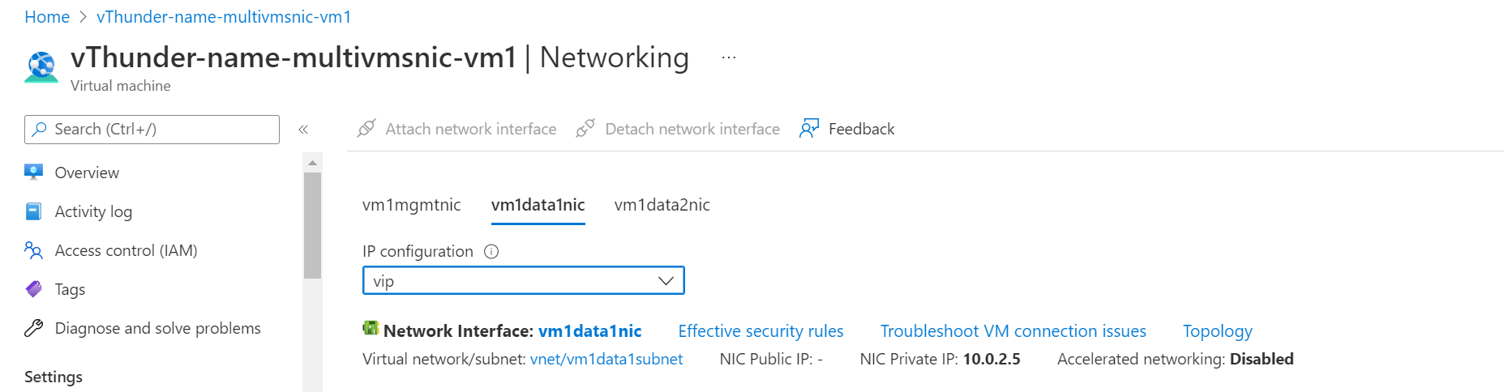
       2. FIP in vThunder-1 server side interface 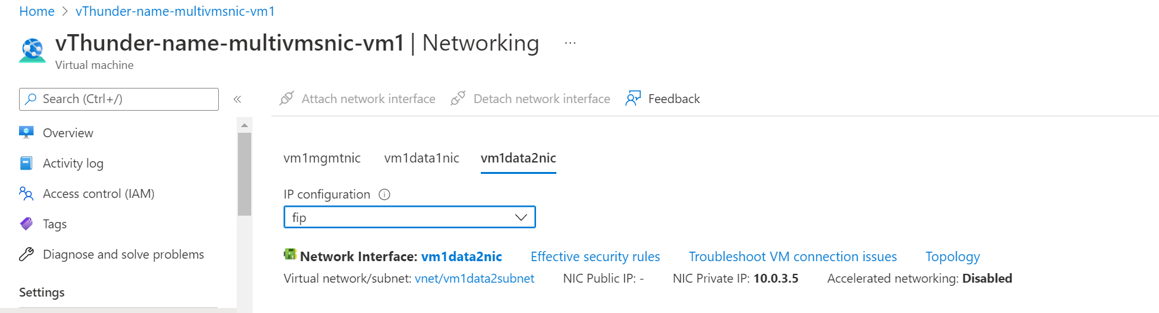
       3. vThunder-1 state 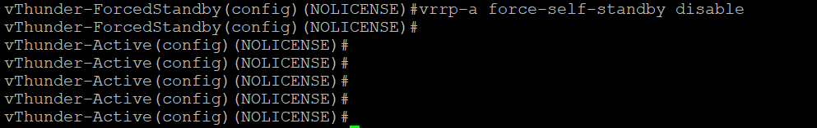
       4. vThunder-2 state 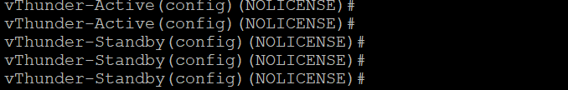
       5. Curl command from client vm 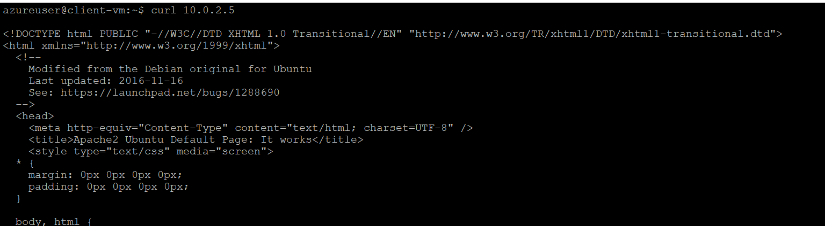

## vThunder-1 and vThunder-2 both are on standby mode

* + 1. Expected Outcome: VIP and FIP will remain where it was. Client vm will not be able to reach Apache server running on server vm.
    2. Actual Outcome: VIP and FIP is remained where it was. Client vm is not able to reach Apache server running on server vm.
       1. vThunder-1 state 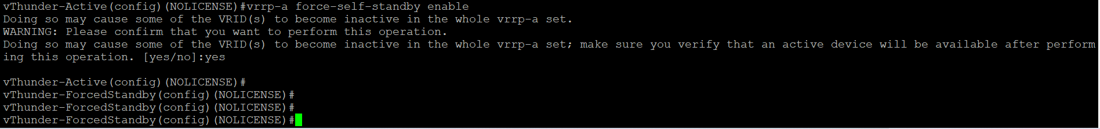
       2. vThunder-2 state 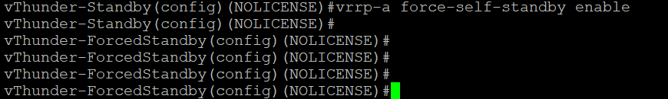

# PS Template – 3 NIC 2 vThunder HA GLM Test Cases

## License Activation

### Activate license

* + 1. Expected Outcome: license will be activated if not activated.
    2. Actual Outcome: license will be activated if not activated.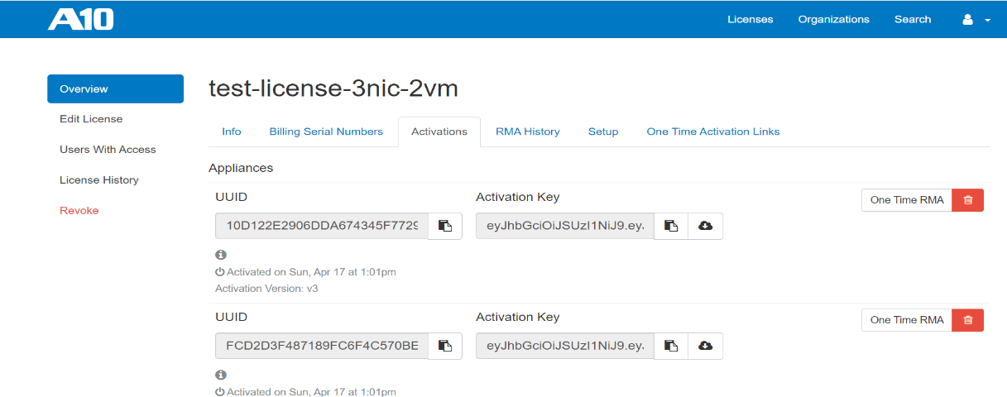

### Apply GLM license

* + 1. Expected Outcome: license will be applied on vthunder
    2. Actual Outcome: license will be applied on vthunder

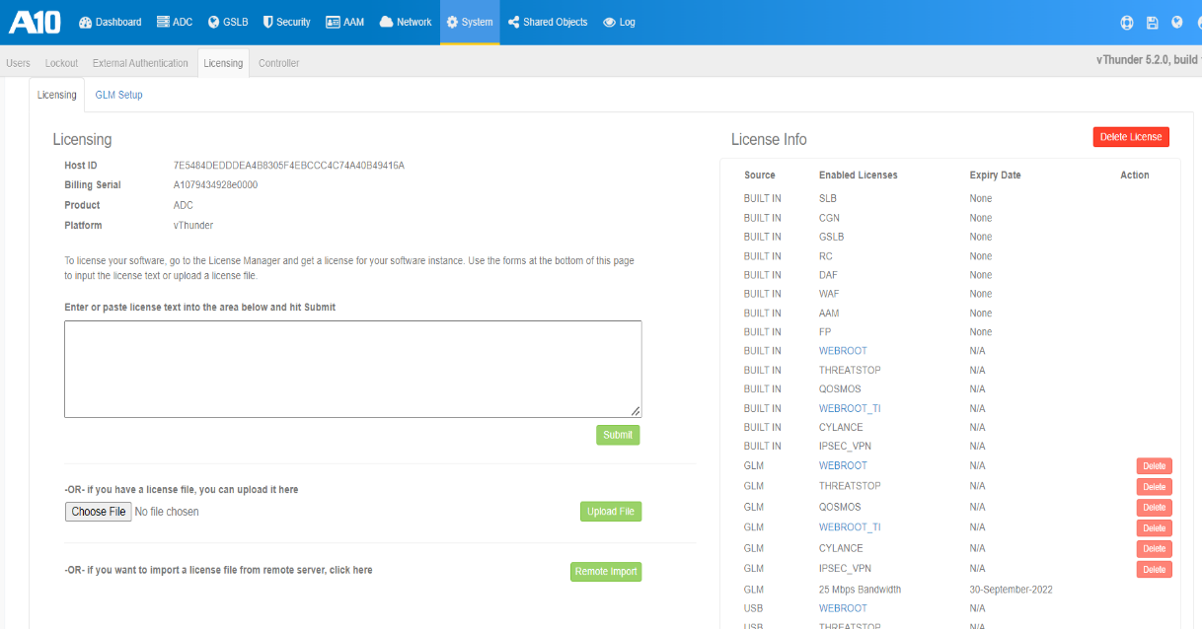

### Set GLM configuration

* + 1. Expected Outcome: primary dns, vthunder entitlement token will be set and glm management port, enable request will be set with value 1
    2. Actual Outcome: primary dns, vthunder entitlement token will be set and glm management port, enable request will be set with value 1

